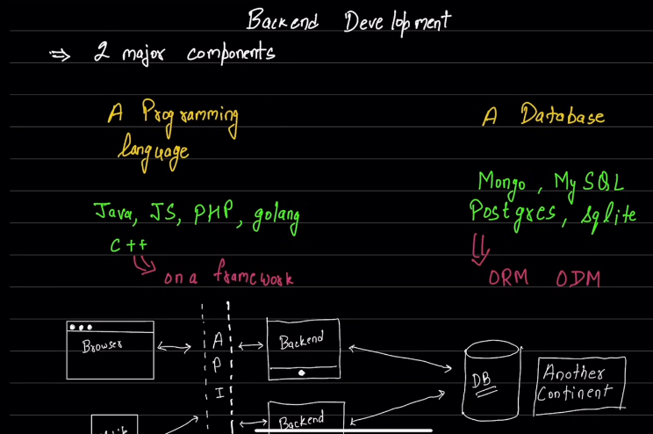

1.c++->crow framework

2.java->spring framework.

3.

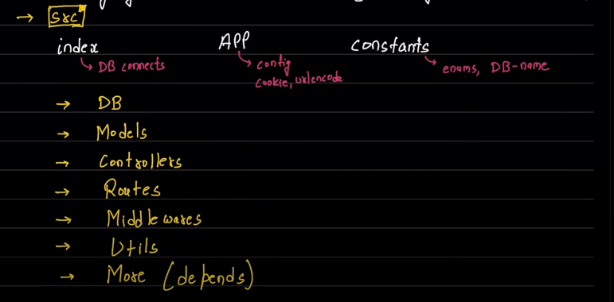

4.node -v ->to determine node js version.

5.npm -v ->to determine npm version.

6. 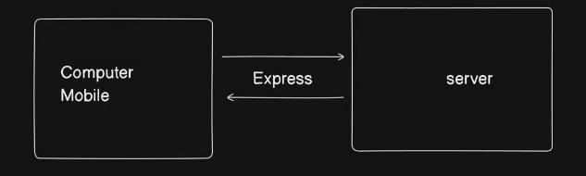

7. /: home route.

/login :login setup

/signup : signup

8.npm init->initialise empty node project.

9.eg code for basic node app .

const express = require('express')

const app = express()

const port = 3000

//       route callback->home

app.get('/', (req, res) => {

  res.send('Hello World!')

})

//       route callback->parth

app.get('/parth', (req, res) => {

    res.send('Hello parth!')

  })

  //       route callback->/hey

  app.get('/hey', (req, res) => {

    res.send('Hello!')

  })

//listeining to port 3000 constantly

app.listen(port, () => {

  console.log(`Example app listening on port ${port}`)

})

10.process.env.Variablename->to use environemnt var.

11.